**Sunkari Manohar**

**Assessment 8 – 20/12/2023**

**Numpy:**

**Creating a two-dimensional array:**

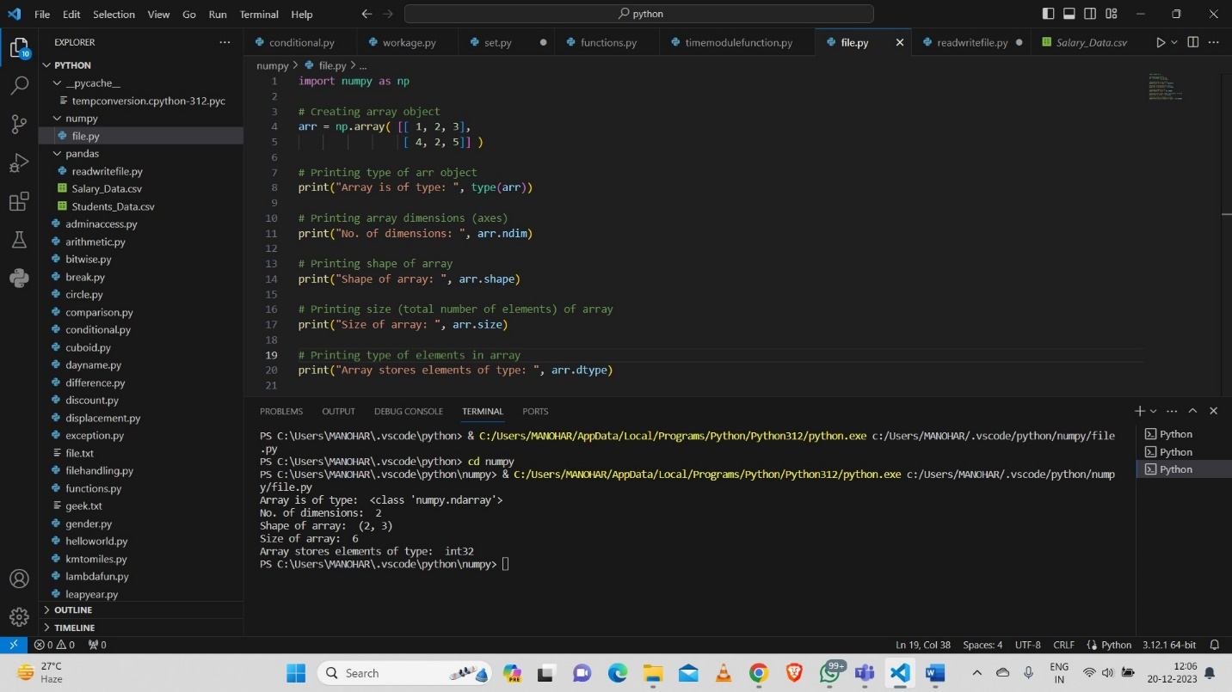

**Created arrays using list and tuple:**

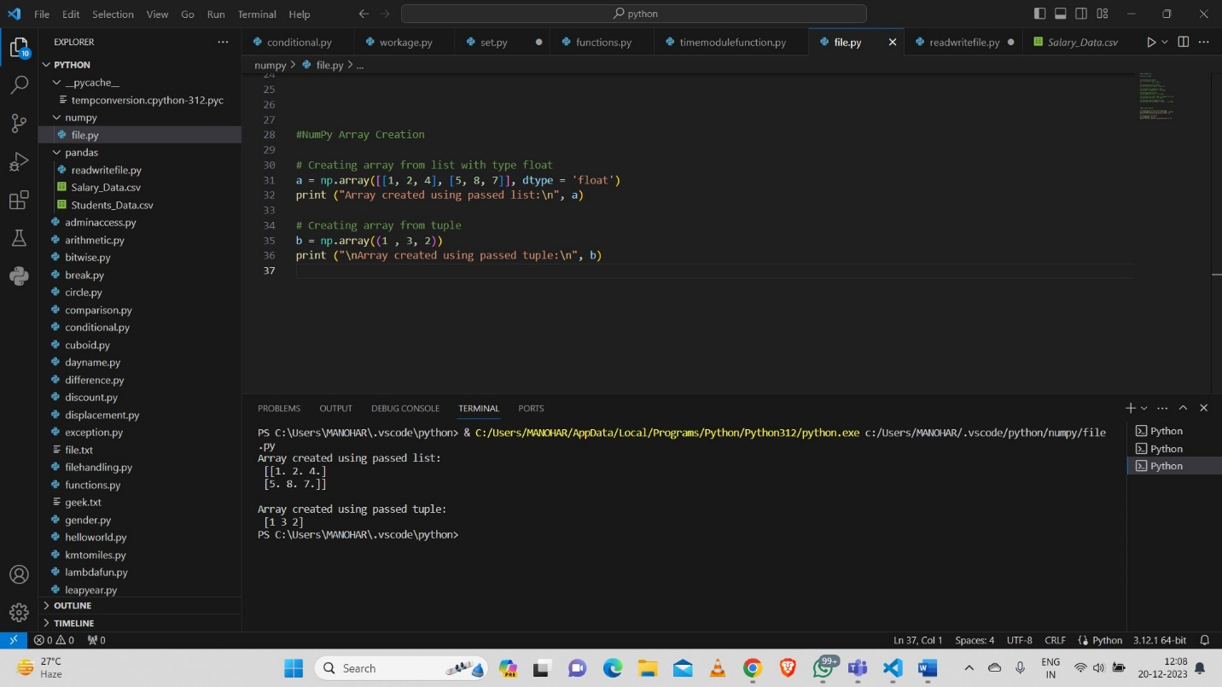

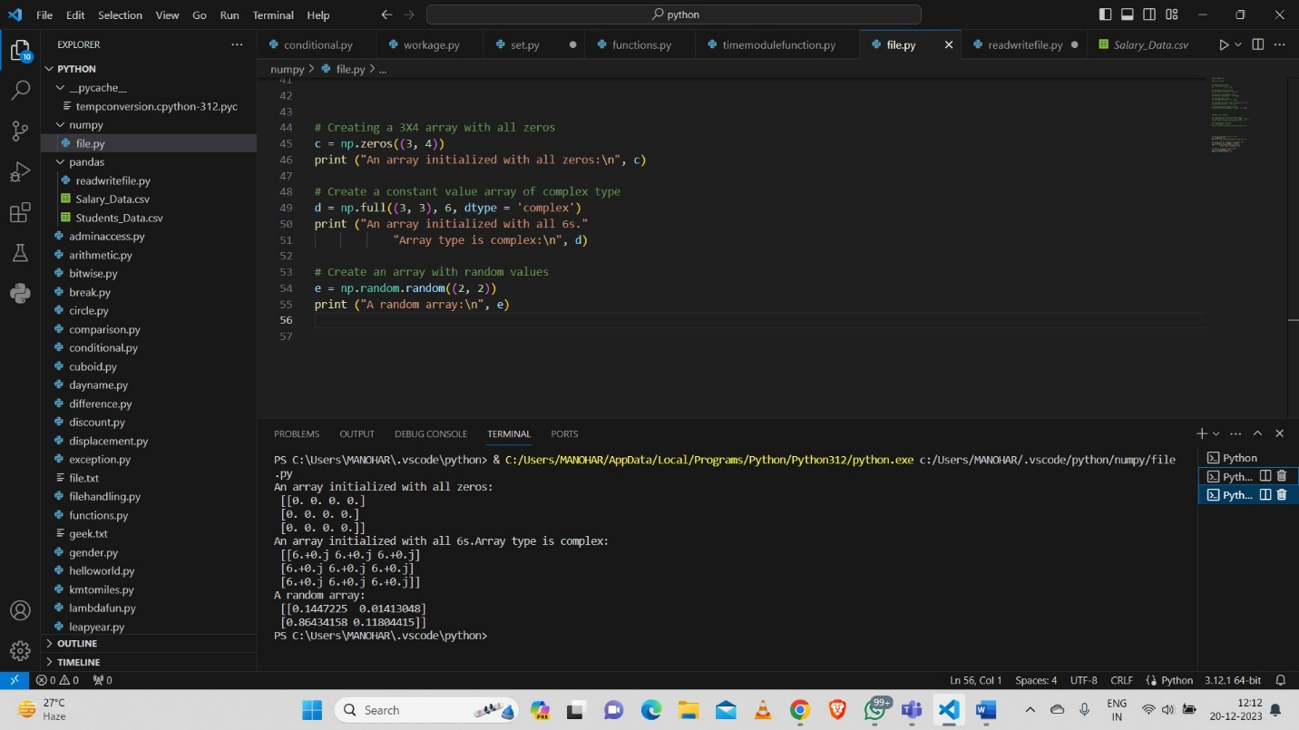

**Sequential array with step count 5:**

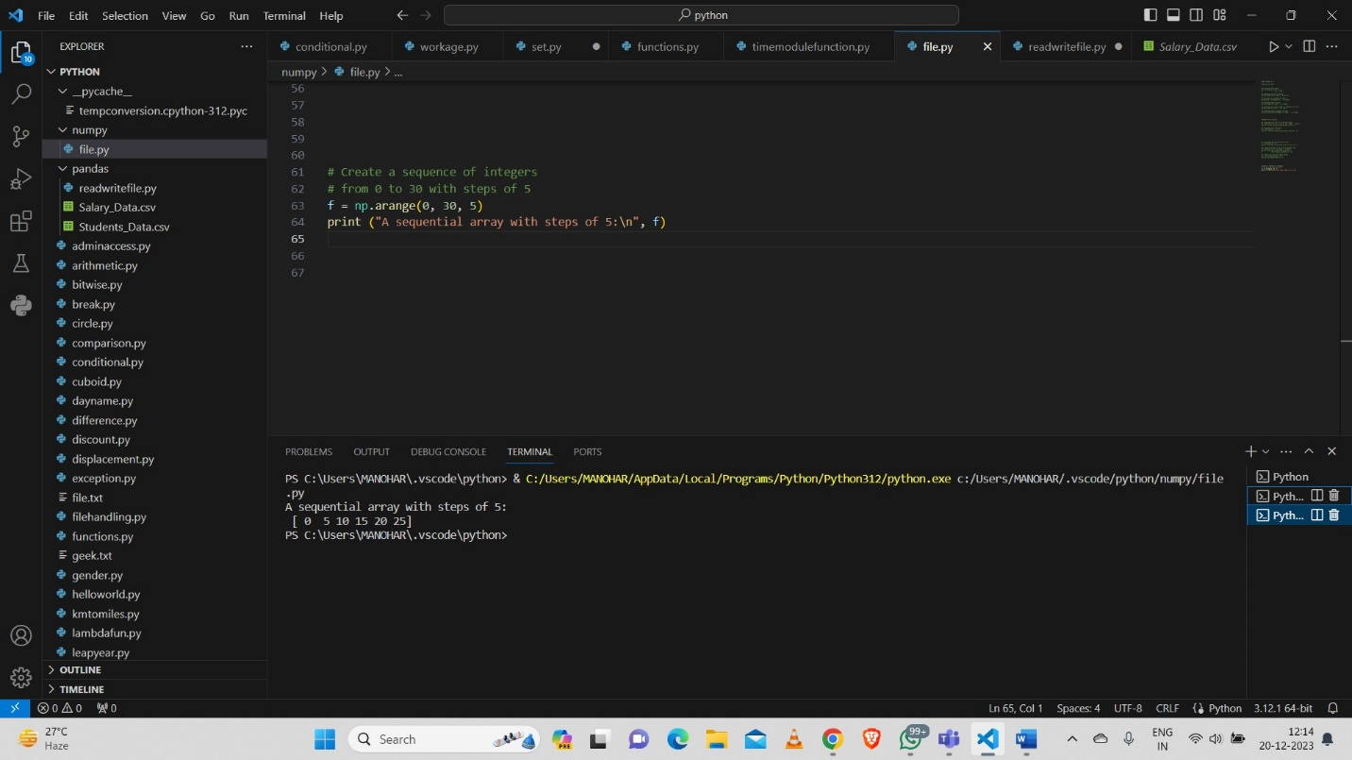

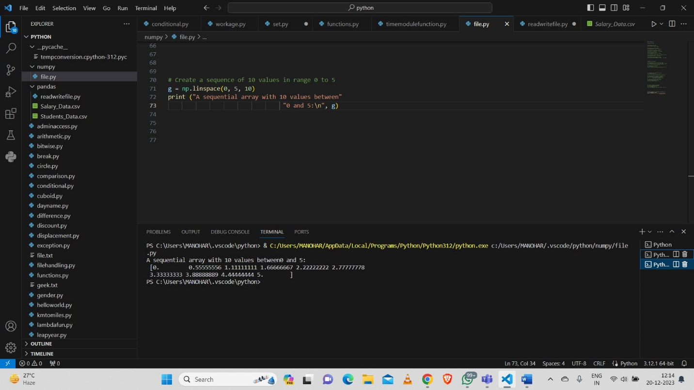

**Reshaping array:**

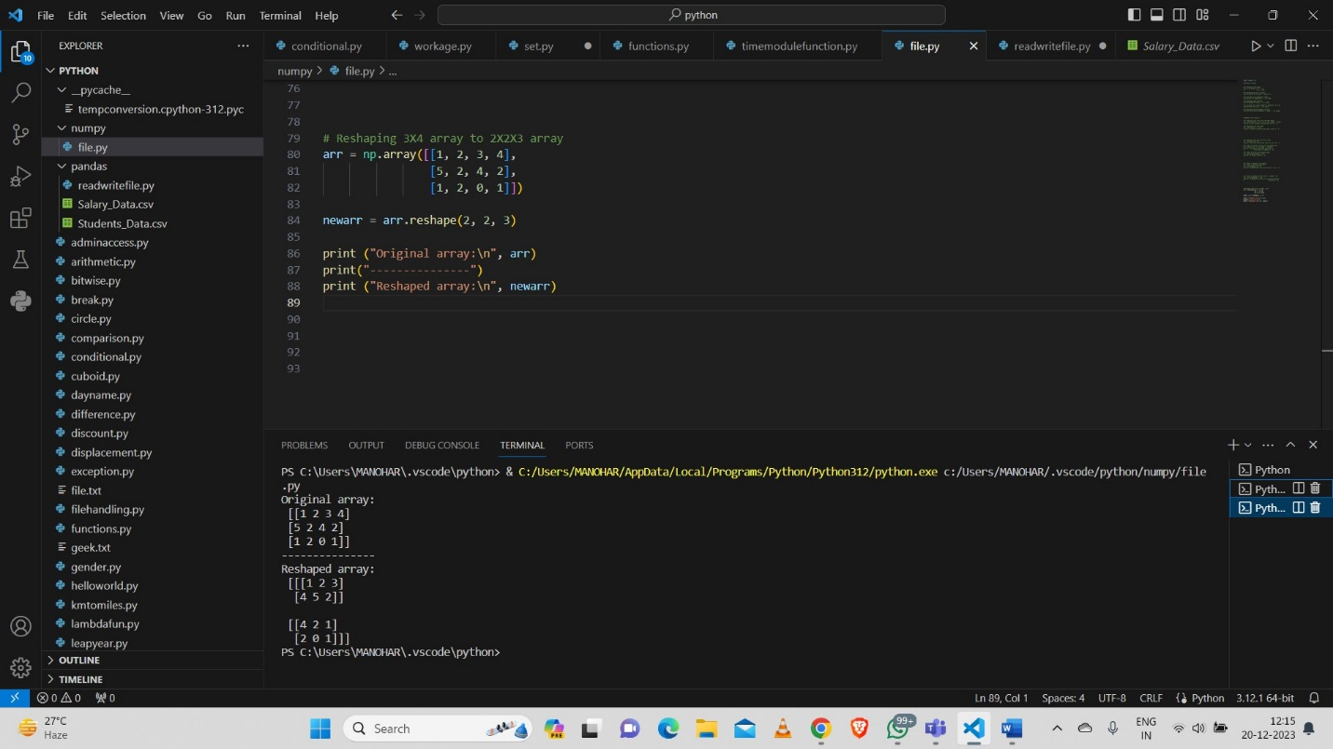

**Flatten array:**

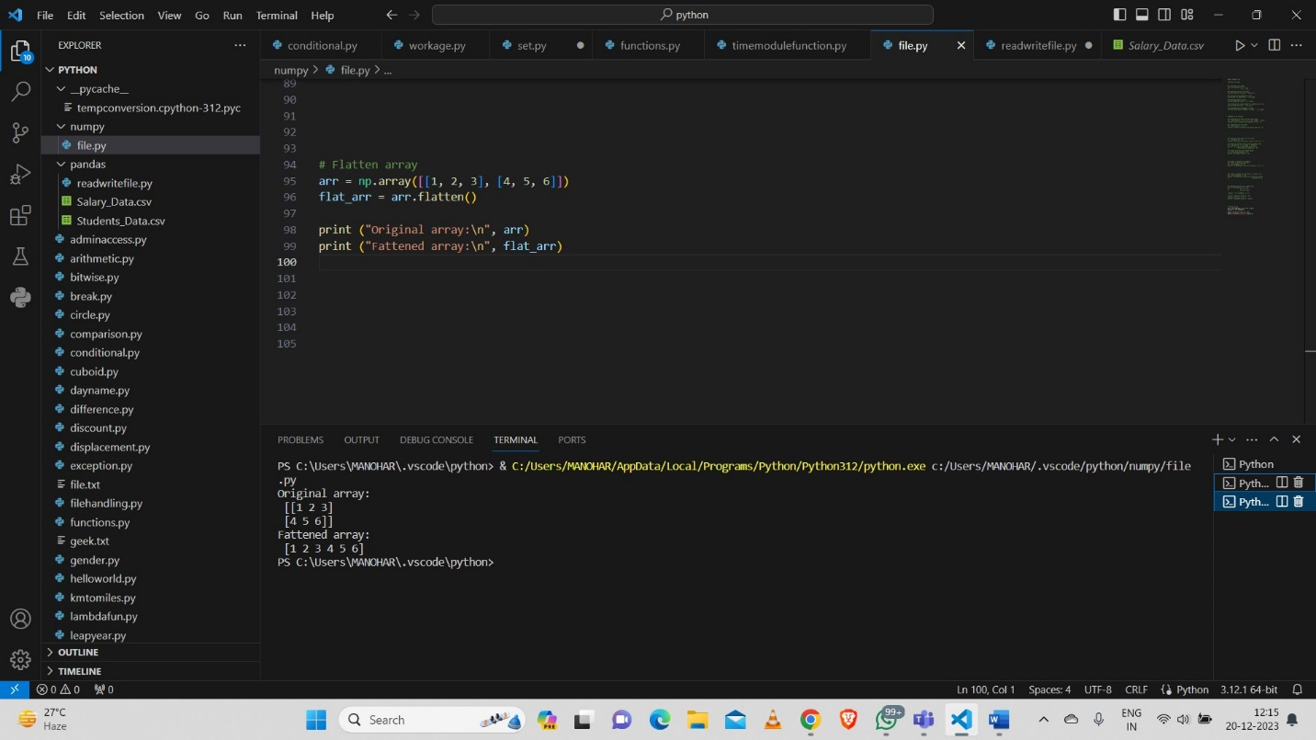

**Array Indexing:**

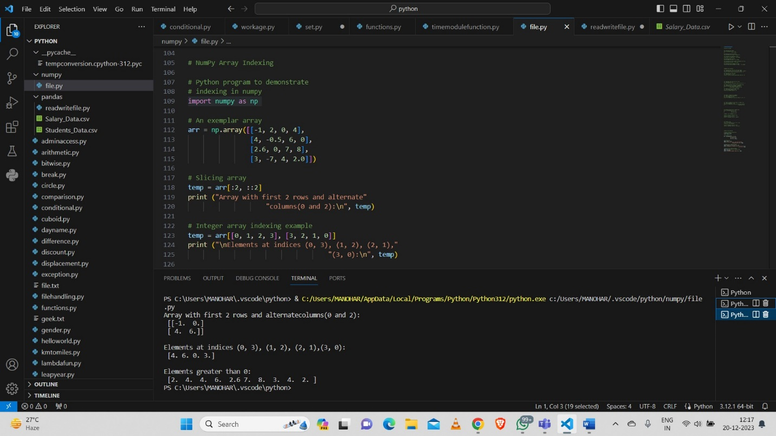

**Basic Operations:**

**Add, Substract, Multiply, Squaring, Double each element**

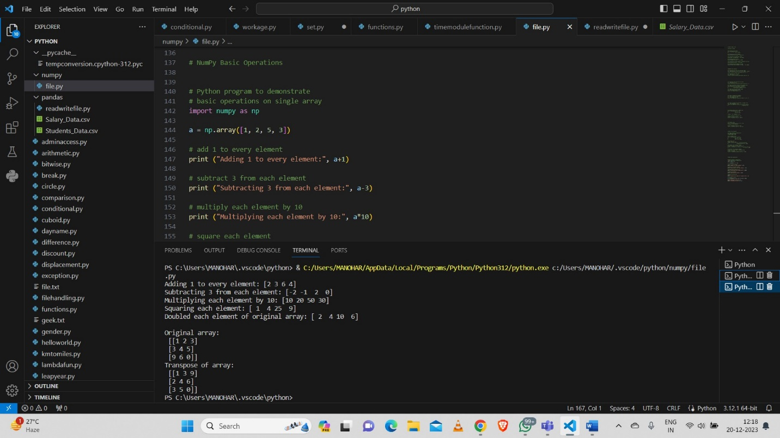

**Unary Operators:**

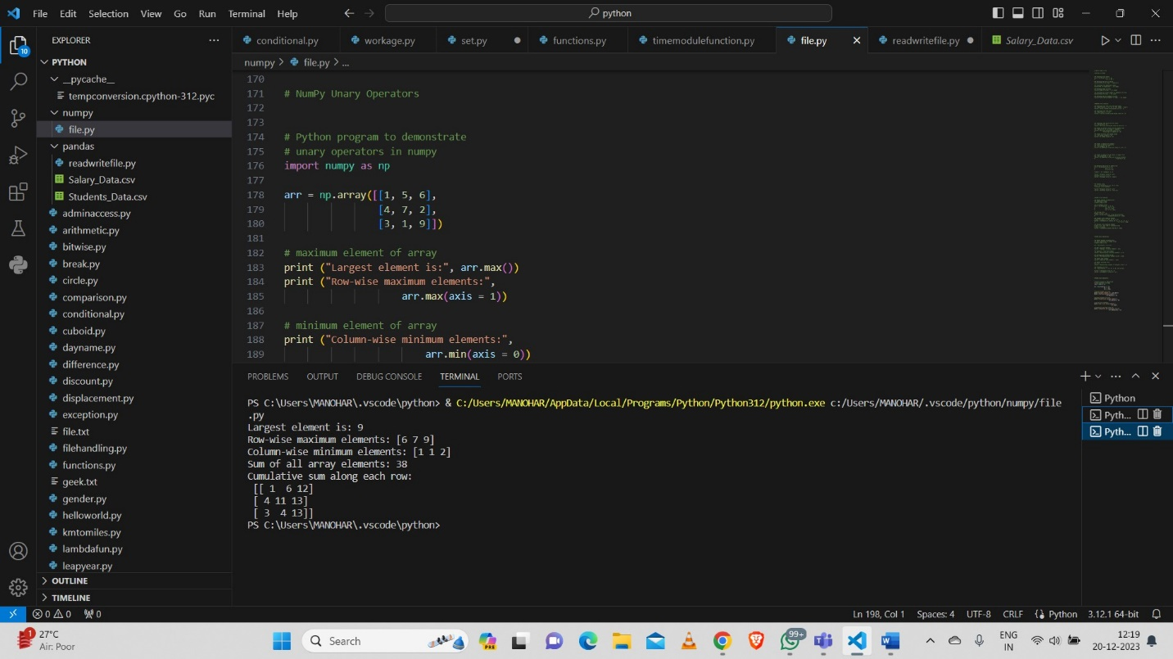

**Binary Operators:**

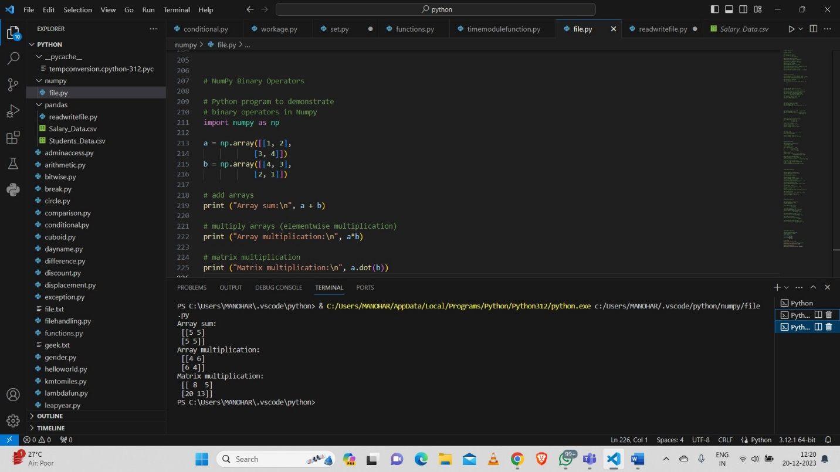

**Universal functions:**

**Sin, exponential, square root of values**

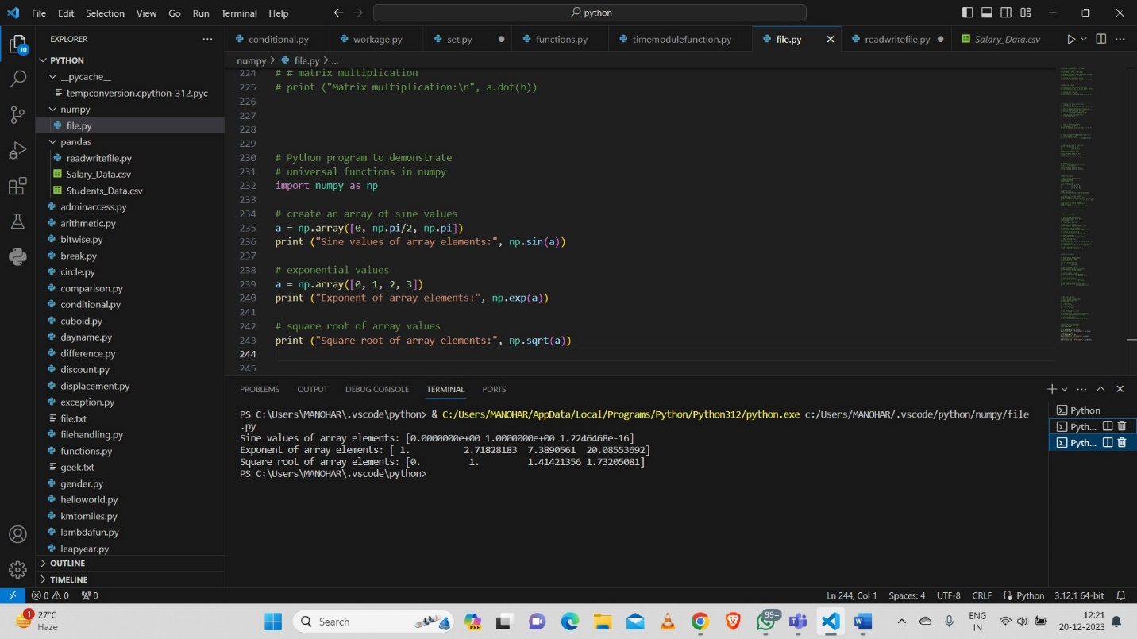

**Sorting Arrays:**

